# **M-VISION, INC.**

M-Vision, Inc. is a deep tech company focused on enabling technology for the defense and automotive markets. The company provides software, hardware, and full-system solutions to industries in these two markets. Its clients include several name-brand OEMs, Tier-1 suppliers, and state and federal government agencies.



## 

## **OUR INNOVATIVE TECHNOLOGY**

M-Vision’s technology portfolio is sensor-driven—camera, infrared, lidar, radar, ultrasound, inertial, and GNSS (GPS). Our in-depth understanding of sensor phenomenology allows us to design our sensor subsystem to maximize signal-to-noise ratio. At the backend of our technology are highly sophisticated computer vision, signal processing, and control algorithms. We implement these algorithms in embedded systems and integrate these subsystems to provide cutting-edge solutions to very practical problems in the industries we serve. We have been granted several broad patents for our technology.

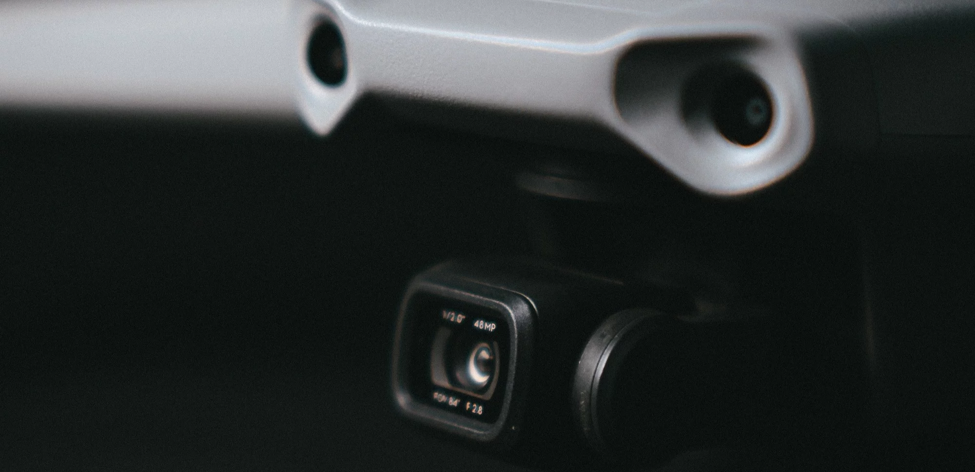

# 

# **OUR BUSINESS**

M-Vision, Inc. is a start-up—a University of Michigan spin-off—that offers cutting-edge technology to the military and commercial markets. The M-Vision team is made up of highly experienced roboticists who have worked with the U.S. Military, Homeland Security and auto companies in the areas of mobility, safety, intelligence, and imaging.

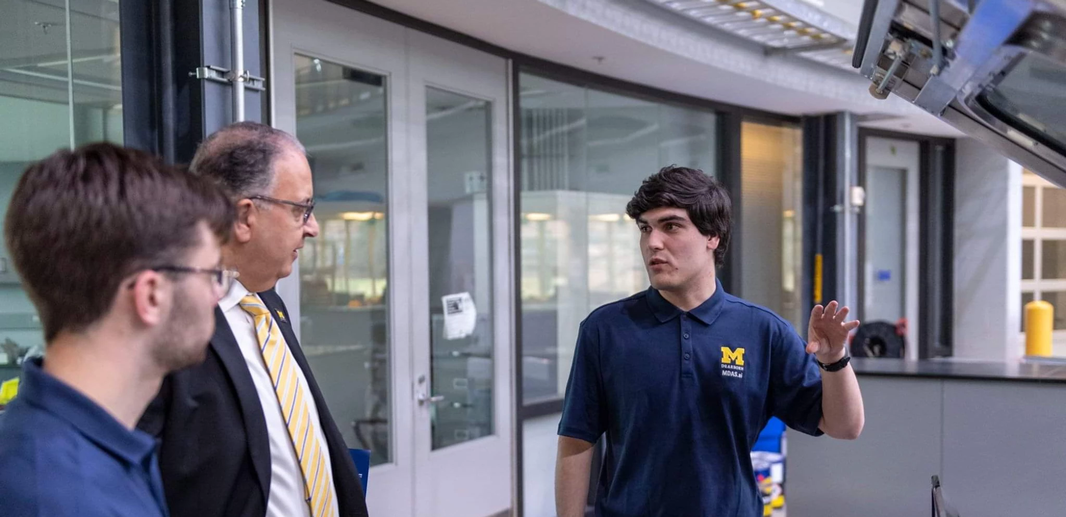

Contact Link: <https://www.m-visioninc.com/contact>